What is La Nina and El Nino?
Sea surface temperatures play a major role in global weather and nowhere is that more evident then in El Nino and La Nina patterns. These type of patterns often lead to weather extremes, some of which can be seen in our own backyards.

La Nina is described as cooler-than-normal sea surface temperatures in the central and eastern Pacific Ocean, near the equator off the west coast of South America. El Nino is like La Nina's brother, the totally opposite and attention grabbing brother. This is described as warmer-than-normal sea surface temperatures in the same area of the Pacific Ocean.
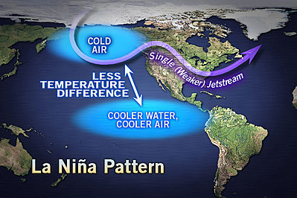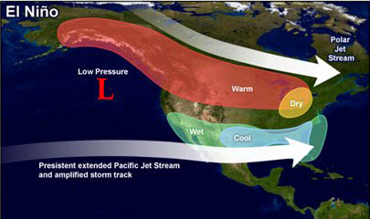

What Does All of This Mean for the Weather?

A typical La Nina winter will feature drier and milder conditions across the South. There could be droughts and elevated fire conditions. The Pacific Northwest will become wetter than normal, while the Northeast will have cold periods, but these are usually short lived.

In an El Nino winter, the southern branch of the jet stream gets displaced across the Deep south, leading to wetter conditions from Los Angeles to the Southeast. The Northeast typically has stormy winters. Finally the Northwest is typically milder.
___________________________________________________________________________________________

