The Proclamation of 1763 Information Sheet
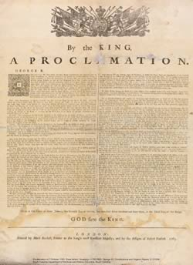
Even after the French and Indian War was over, British soldiers stayed in the Ohio River Valley to keep order. Most of the American Indians wanted the soldiers to leave the area. An Ottawa chief named Pontiac led the Indians in a war against the British called Pontiac’s Rebellion. After much bloodshed, the British defeated the Indians but tensions remained high. In an effort to avoid more conflict and tension with American Indians, King George III issued the Proclamation of 1763. It recognized the Indians’ right to the land and it did not allow colonists to settle west of the Appalachian Mountains. This made colonists very angry because they wanted to settle on the land and they did not want British soldiers to live among them. Because the Proclamation was difficult to enforce, many colonists disregarded it, which showed their unhappiness with British attempts to control them

