Tea Act & Boston Tea Party Information Sheet
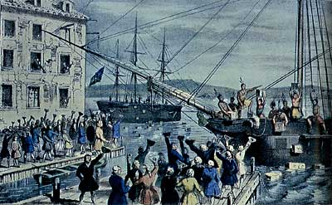
In 1773, Parliament passed the Tea Act which made the British East India Company (BEIC) the only company allowed to sell tea to the colonies, which made this a monopoly over tea. The price of tea was actually much lower, but colonists were still unhappy that they were forced to pay import taxes to Britain. In order to avoid paying these taxes, colonial merchants refused to unload the tea from the British ships or sell the tea in the colonies. The Daughters of Liberty contributed to the boycott efforts by making their own tea.
On December 16, 1773, some Sons of Liberty, disguised as American Indians, illegally boarded the ships and dumped 342 crates of British tea into Boston Harbor. This protest was called the Boston Tea Party.

