Quartering Act
Information Sheet
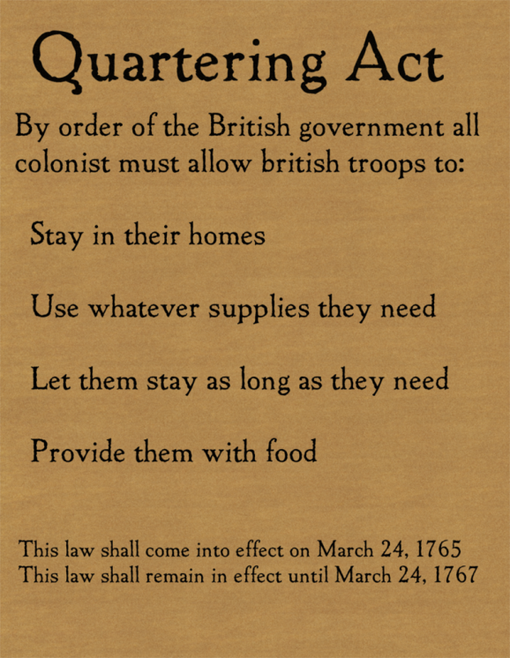
After the Stamp Act protests, Britain sent even more troops to keep order in the colonies. Due to the social and political problems that took place in the colonies after the Stamp Act, the British Parliament also passed the Quartering Act of 1765. This act required colonists to quarter, or house and feed British soldiers.
There were two major issues the colonists had with the Quartering Act. The first was that colonists did not like having a standing army of soldiers with blank search warrants, or writs of assistance. They had lost their sense of rights over their property. The other issue was that housing and supplying the soldiers was costly. The British response was that the colonists should pay their share of the expense of providing them with the protection from Indian attacks. In addition, the soldiers began taking jobs at a lower wage which further outraged colonists and increased tension between the colonies and Britain.

