Navigation Acts
Information Sheet
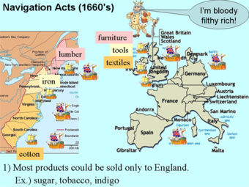
The Navigation Acts were efforts to put the theory of mercantilism into actual practice. Beginning in 1650, Parliament acted to combat the threat of the rapidly growing Dutch carrying trade.

Under the provisions of this legislation, trade with the colonies was to be conducted only in English or colonial ships. Certain "enumerated" items (such as sugar, tobacco and indigo) were to be shipped only within the empire. Trade destined for nations outside the empire had to go first to England. Some of the legislation was designed to protect colonial interests. For example, tobacco production in England was prohibited, leaving the colonies as the sole source of that lucrative product.

The American colonists were never fully comfortable with those laws, but became ardently opposed with the passage of the Sugar Act of 1733. Under that law, a duty was placed on the importation of sugar from the French West Indies, forcing the American rum distillers to buy more costly sugar from the British West Indies.

When Britain decided to step up enforcement of the Navigation Acts and other trade acts, Vice-Admiralty courts were set up to bring criminal charges for smuggling. Defendants were assumed guilty until he proved himself innocent. Parliament also passed the Currency Act in 1764 which assumed control of the colonial currency system. There were no gold or silver mines and currency could only be obtained through trade as regulated by Britain.

The most significant result of the Navigation Acts upon American history was the stifling of colonial manufacturing and increased resentment against the mother country.

